**Team 1:**

**Group Members:**

**Sai Varsha Vellanki**

**Sreenidhi Madala**

**Application Name: Gift Vouchers**

**Purpose of the Application:**

The gift center is an android app that lets users to purchase and redeem gifts. To do so the user must be registered first. Then after registration the user's details are stored in firebase real time database. So, when they want to purchase/redeem gifts they will have to login using the email they entered during registration together with the password.

During login, the email and password are verified by the app by checking in the firebase database if there are any credentials which match with the login request. IF THEY EXIST then the user gets a message that login was successful, and they will have access to the full features of the app which include:

1. **Updating profile details**
2. **Changing/resetting password**
3. **Redeem gifts**
4. **Purchase gifts**
5. **Listing both redeemed and purchased gifts**

**Risks Involved in our application:**

1. Did not need outside API
2. Authenticating card details providing by users

**Required Functionality:**

1. Need to authenticate users
2. They must input a pin code that will be used when they decide to redeem the same gift.
3. Validating card [credit/debit]
4. Validating vouchers while redeeming

**Layouts involved in the App:**

1. **Launch/Login Screen:**

This page allows user to either login or get Register if not registered

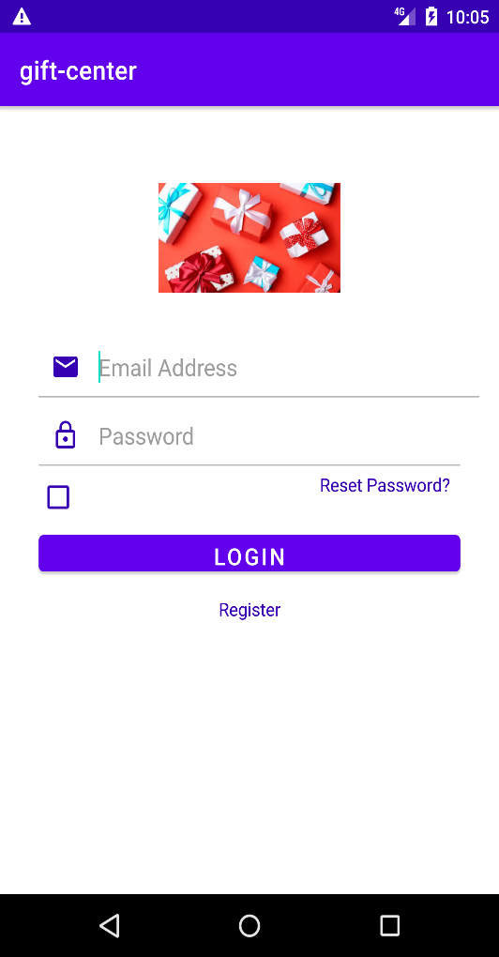

**Sign up Screen:**

User who wants to buy vouchers using this app can register to login into the app by providing their details.

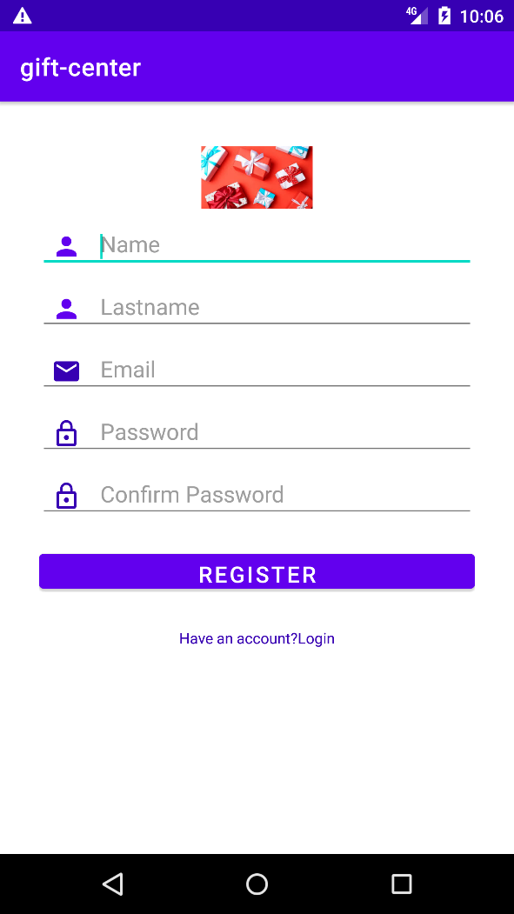

**Change Password Page:**

Change Password page to change our password.

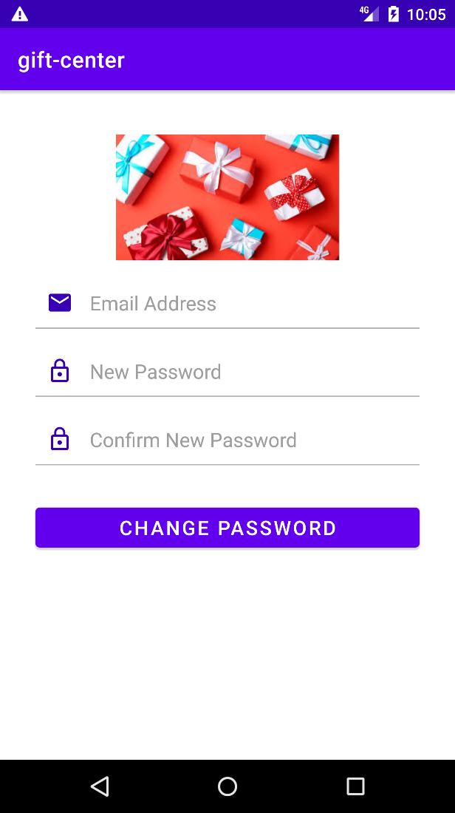

**Home Page:**

This page will lead to main page of this app.

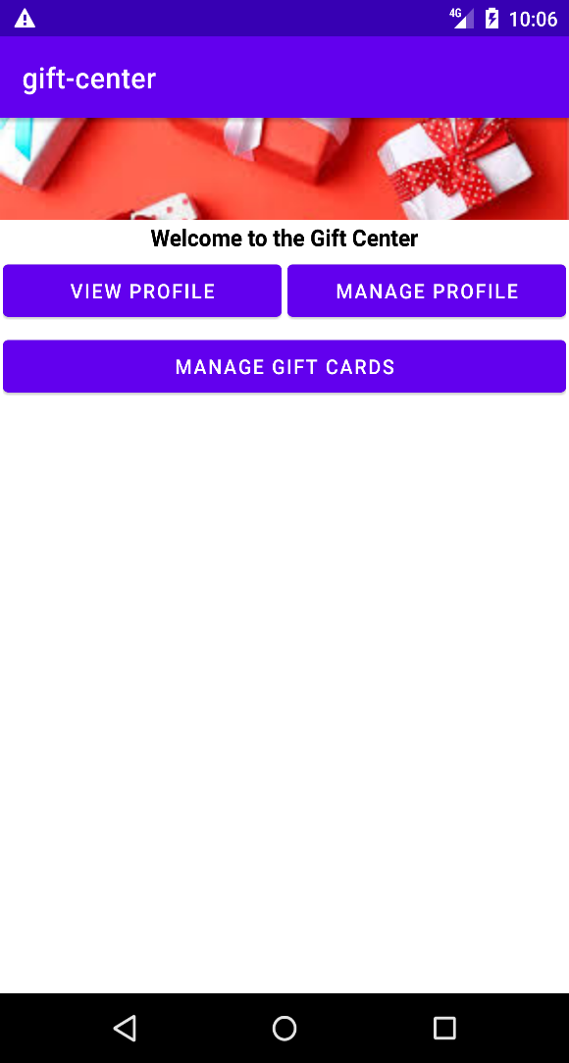

**Profile Page:**

This page will show all the details of the user.

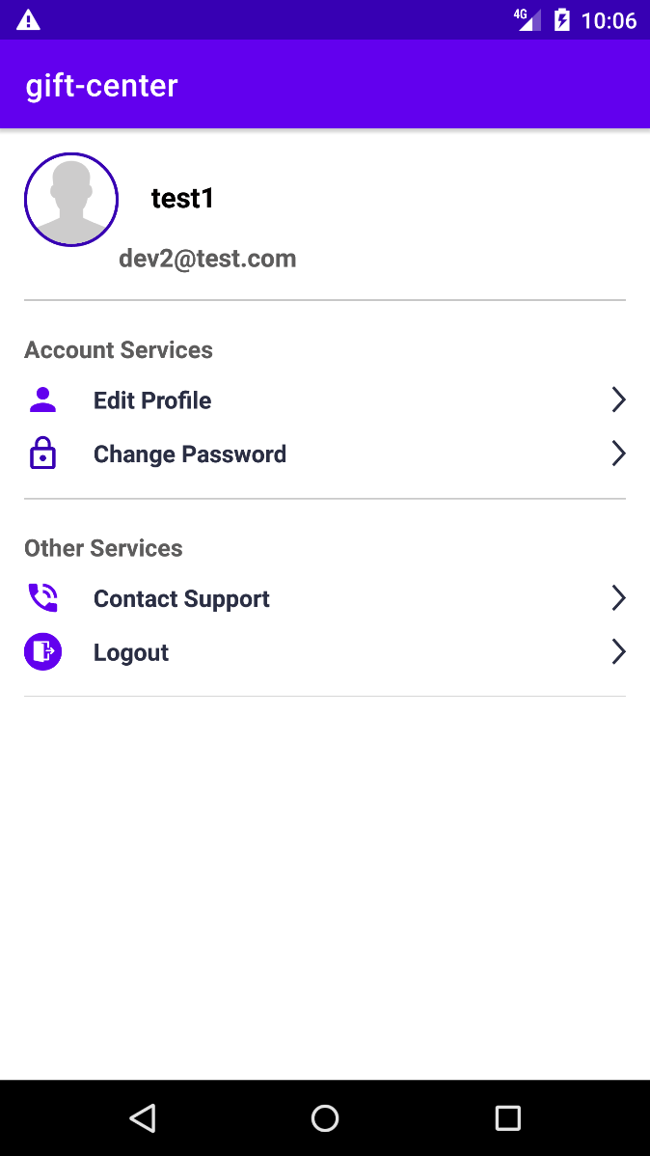

**Update Profile Page:**

In this page we will have an option to update profile.

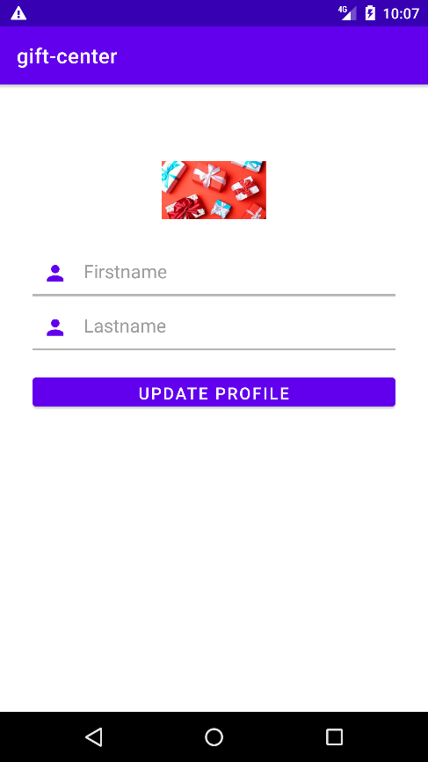

**Note:** For this application we will be using dummy data which we store it over the network.